**TITLE OF RESEARCH PROJECT**

‘CogBeacon: Towards detecting cognitive fatigue’

**RESEARCH TEAM**

Michalis Papakostas (PI): Department of Computer Science and Engineering: michalis.papakostas@mavs.uta.edu

Akilesh Rajavenkatanarayanan (Co-PI): Department of Computer Science and Engineering: akilesh.rajavenkatanarayanan@mavs.uta.edu

Fillia Makedon (Faculty Advisor): Department of Computer Science and Engineering: makedon@uta.edu

**IMPORTANT INFORMATION ABOUT THIS RESEARCH PROJECT**

Cognitive fatigue, which is different from but related to physical fatigue, is a prevalent symptom in numerous real-world applications such as, healthcare, transportation safety, and in the industrial workplace. It is considered an “invisible” safety risk, often going undetected and untreated, and it can cause impaired judgment and other symptoms. For example, consider a school bus driver who is so fatigued that he misses a stop sign; or an airport security officer who fails to recognize a gun inside a passing bag; or a nurse or doctor who administers the wrong medication; or a lecturer who makes mistakes, impacting the quality of education.

The research team above is conducting a research study that will investigate the impact of mental exhaustion (cognitive fatigue) on user’s performance when performing a cognitive task. In the future, this study will help us build assessment and rehabilitation systems which would detect fatigue and can adapt accordingly. You can stop the study at any time with no consequences. Refusal to participate or discontinuing your participation at any time will involve no penalty or loss of benefits to which you are otherwise entitled. Please ask questions if there is anything you do not understand.

**Inclusion Criteria:**

You must be 18 years or older, and you have to:

1. Follow all UTA rules (e.g. prohibited tobacco consumption on campus).

2. Accept to follow the experimental procedure. For example, to be considered in the study, the participants must accept to wear the MUSE EEG sensor and agree to play the cognitive game. Otherwise, they have the right to withdraw from the experiment at any time without consequences.

3. In the experiment can participate only adults (student, faculty and personnel) who are affiliated with UTA.

**Exclusion Criteria:**

To participate in this study, participants must not have any of the following cognitive or physical disabilities: any kind of upper limb mobility limitations, severe visual impairments (people wearing glasses or contacts are not considered as ‘*severe’ cases* for the purposes of this study), cognitive and/or physical impairments related to Parkinson’s disease, Dementia, Multiple Sclerosis, Down syndrome or similar diseases that have a chronic impact on the nervous system. Moreover, you should not be under medication that can cause drowsiness and/or sleepiness.

You might want to participate in this study if you would like to contribute to our research to understand fatigue and its impact on human performance. This would help us to build systems that can detect fatigue and provide feedback to users while performing their daily activities.

However, you might not want to participate in this study if you feel uncomfortable wearing the MUSE EEG sensor and/or performing a cognitive task. Note that MUSE EEG device is an off-the-shelf headset available for purchase at stores and online platforms (such as Amazon or Best Buy). If you are concerned about the risk of tiredness, (ie. being mentally fatigued) you have the right to withdraw from the study without any penalty.

This study has been reviewed and approved by an Institutional Review Board (IRB). An IRB is an ethics committee that reviews research with the goal of protecting the rights and welfare of human research subjects. Your most important right as a human subject is informed consent. You should take your time to consider the information provided by this form and the research team and ask questions about anything you do not fully understand before making your decision about participating.

**TIME COMMITMENT**

You will be asked to participate in this study twice on the UTA Campus in Arlington, Texas at room ERB 313. Each session will last approximately 30 minutes or less. Your second participation will take place at least 2 days after your first visit. In both visits you will have to perform very similar activities with minor variations.

**RESEARCH PROCEDURES**

In this experimental study, if you decide to participate this is the list of activities you will be asked to perform:

• Read through this Informed Consent and talk with the research team to make sure that any questions you may have are answered; then make your choice about whether to participate.

• The researchers will then explain the setup and the study. If you have any questions, please feel free to ask the researchers.

• The researchers will then mount the MUSE EEG sensor on to you and make sure you feel comfortable. The EEG will be mounted using a headband on the front of your head. Video of the performance will also be recorded. Muse is an off-the-shelf device available for purchase by anyone in stores. Pictures of the device can be found below.

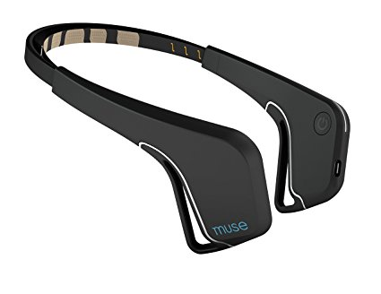  
Figure 1: The MUSE Device

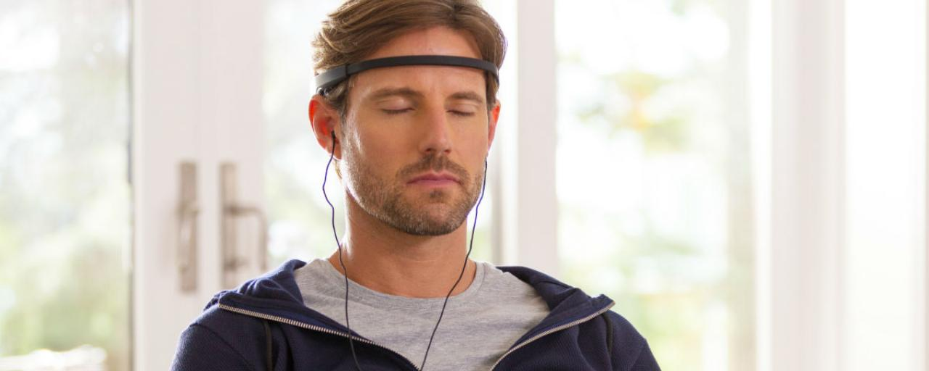  
Figure 2: A user wearing the MUSE device

• After each task, you will be provided with a survey where you will give feedback about your experience. The surveys will be provided to you as hard copies and your responses will be stored securely in the Heracleia Lab at UTA room ERB 313.

• Data from the sensors will be recorded while you perform the series of tasks explained below:

Task 1: Play a simple computer-based game that mimics the rules of a popular cognitive test, known as the Wisconsin Card Sorting Test.

The rules of the game are the following:

In each round, you will be given a card which you will have to classify to one of four possible categories based on different criteria. One can classify a card according to the color of its symbols, the shape of the symbols, or the number of the shapes on each card. Once you classify a card based on one of the aforementioned decision rules you will get feedback from the system that will indicate whether your decision was right or wrong. If the feedback is positive it means that you have picked the correct rule and you should keep classifying the next card based on the same rule. If the feedback is negative it means that the rule you chose was wrong and you need to change your decision-making rule. The decision rule changes every N rounds where N is at least 6. Once the decision rule has changed you will have to figure out the new rule based on the feedback you get by the system. You will play in total 60 rounds, ie. you will be asked to classify 60 different cards. The task aims to measure how well someone can adapt to the changing rules.

**Example:**

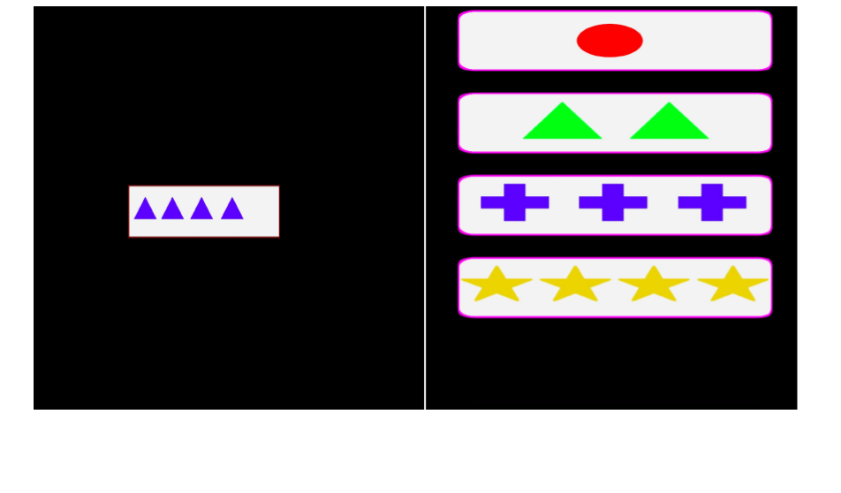

Here, on the left side of the screen, you are given a card with “Four Blue Triangles”. On the right side of the screen are four buttons. Each button corresponds to one of the four possible categories that you should assign the card on the left. If you choose to classify based on the color you should press the button with the “Three Blue Crosses”. If you decide to classify based on the shape you should press the button with the “Two Green Triangles”. Lastly, if you decide to classify the card based on the total number of shapes that appear on the card you should press the button with the “Four Yellow Stars”. Based on your pick and the correct rule that applies at each point you will get feedback by the system. Based on the feedback, you are responsible to evaluate if your decision rule was correct or if you have to change your decision-making strategy. Figures below show screenshots from the positive and negative feedback provided by the system.

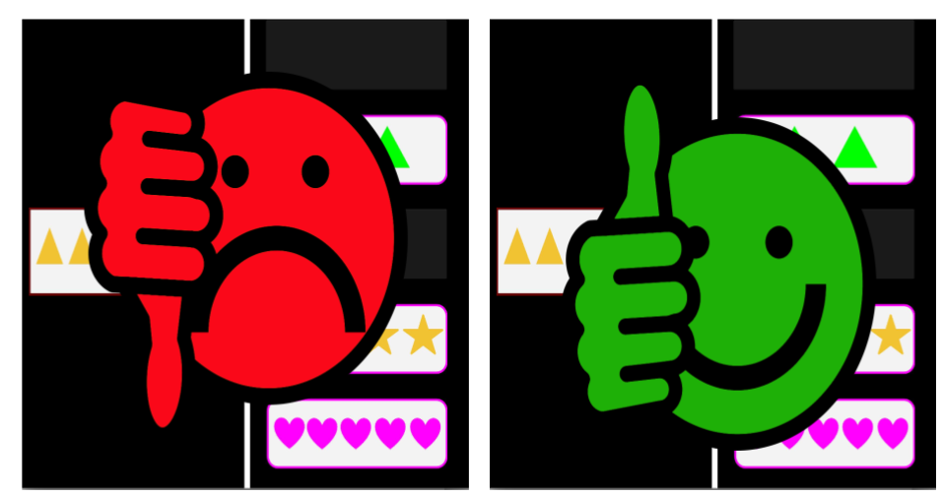  
Figure 3: Left screenshot shows system's negative feedback. Right screenshot shows system's positive feedback. You will get a feedback after every decision. Each feedback will be accompanied with an intuitive sound. A “buzz” sound for negative feedback and a “bell ring” sound for positive feedback.

Task 2: In the second step you will have to play a slightly modified version of the same game. The rules that apply are the exact same as before except two main differences. Firstly, occasionally will appear a fifth category on the right side with “Five Magenta Hearts” and secondly the total number of possible categories will vary after every rule change. Other than that the exact same rules apply. Participants will have to play 128 rounds of this game, ie. classify 128 different cards. Example screenshots of the modified version are shown below.

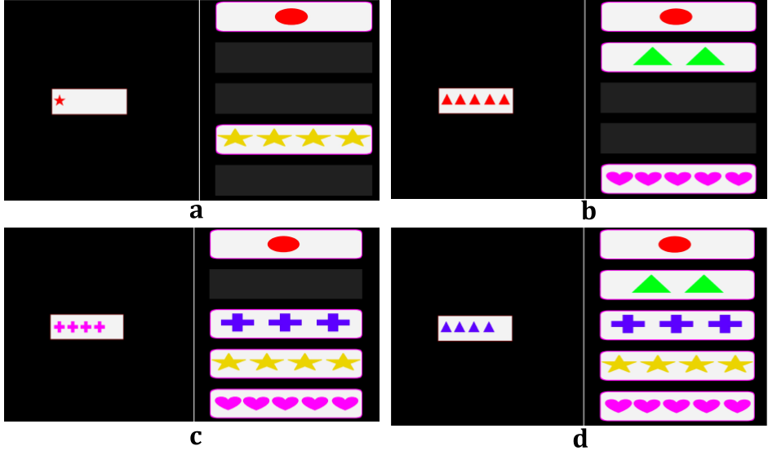

In both tasks there will be a red button placed in front of you.You are expected to press the button whenever you personally feel that you have trouble keeping up with the task. This might be due to boredom, tiredness, difficulty to figure out the correct rule, background noise (ie. people talking behind you) or any other reason **that you feel** that impacts your performance negatively in the task. Pressing the button will be an indication for the research team that you are facing some kind of difficulty. You can press the button multiple times during the game if and when such conditions occur. A button press will not affect anything on the game itself. You will still have to complete all the rounds until the end of the game, except if you decide that you don't want to participate anymore in which case you can remove the MUSE device from your head and let the researcher know. You can withdraw anytime with no consequences.

Participants will have to repeat almost the same process on both visits.

**POSSIBLE BENEFITS**

This research might not be of direct benefit to you. The results of this project may give us valuable insights regarding the impact of cognitive fatigue on user performance. In the future, this may help us to build adaptive assessment and rehabilitation systems.

**POSSIBLE RISKS/DISCOMFORTS**

In this study, you will be asked to wear the MUSE, a non-invasive EEG headset. If you feel minor discomfort because of the EEG headset please let the study personnel know. If the discomfort is annoying or unbearable, please let the study personnel know, take off the headset and move away and the study personnel would shut down the experiment immediately.

You have the right to quit any study procedures at any time at no consequence and may do so by informing the researcher.

**COMPENSATION**

You will receive no compensation in this experiment.

**ALTERNATIVE OPTIONS**

There are no alternative procedures offered for this study. Participation in this research study is voluntary. However, you can elect not to participate in the study or quit at any time at no consequence.

**CONFIDENTIALITY**

The research team is committed to protecting your rights and privacy as a research subject. Non-identifiable data like EEG data or task-based performance metrics may be shared with the research community, using online databases like such as Github or Physionet. Identifiable data like recorded video while playing the computer games will be stored in UTA encrypted hard-drives in the Heracleia Lab at UTA room ERB 313. Hard copies of the survey responses will also be stored securely in UTA, room ERB 313. Identifiable data will not be shared with anyone outside the research team. Your name will only be recorded on your consent form. All data will be coded using user IDs. Our team will not keep a Master list that associates users, user names and/or user emails with user IDs. Thus, it will not be possible to match your identity with any of the collected data after you leave the lab (ERB 313), including the signed consent form. Surveys, video recording, eeg data, task performance data and “red button” responses will all be coded using user IDs. The results of this study may be published and/or presented without naming you as a participant. The data collected about you for this study may be used for future research studies that are not described in this consent form. If that occurs, an IRB would first evaluate the use of any information that is identifiable to you, and confidentiality protection would be maintained.

While absolute confidentiality cannot be guaranteed, the research team will make every effort to protect the confidentiality of your records as described here and to the extent permitted by law. In addition to the research team, the following entities may have access to your records, but only on a need-to-know basis: the U.S. Department of Health and Human Services and the FDA (federal regulating agencies), the reviewing IRB, and sponsors of the study.

**CONTACT FOR QUESTIONS**

Questions about this research study or reports regarding an injury or other problem may be directed to Michalis Papakostas (michalis.papakostas@mavs.uta.edu) or to the faculty advisor Professor Fillia Makedon (makedon@uta.edu). Any questions you may have about your rights as a research subject or complaints about the research may be directed to the Office of Research Administration; Regulatory Services at 817-272-3723 or regulatoryservices@uta.edu.

**CONSENT**

By signing this form, you are confirming that you understand the study’s purpose, procedures, potential risks, and your rights as a research subject. By agreeing to participate, you are not waiving any of your legal rights. You can refuse to participate or discontinue participation at any time, with no penalty or loss of benefits that you would ordinarily have. Please sign below if you are at least 18 years of age and voluntarily agree to participate in this study.

**________________________________________________________________________**

**SIGNATURE OF VOLUNTEER                                                             DATE**

***\*If you agree to participate, please provide the signed copy of this consent form to the research team. They will provide you with a copy to keep for your records.***